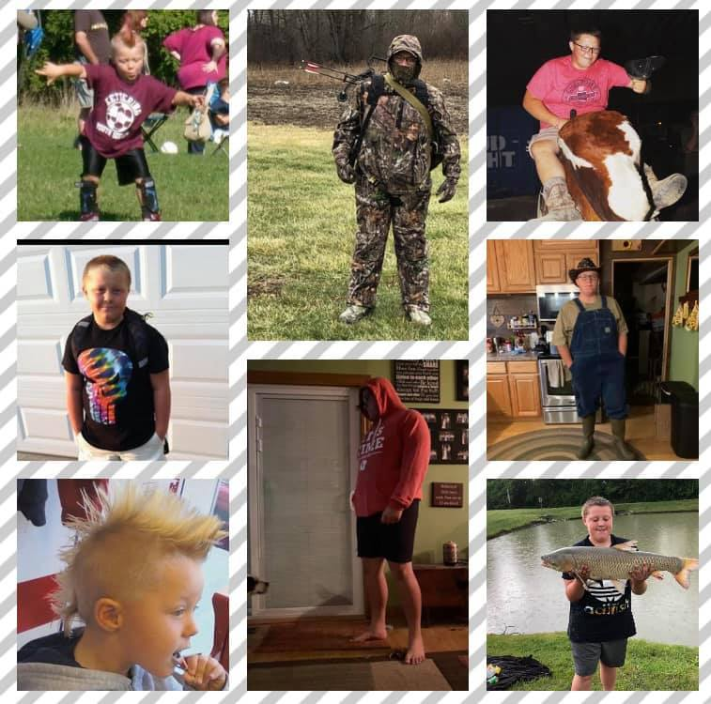  Sunday, January 31, 2021 at 12 PM  Please join us as we help  Gavin’s Fight  The Madison Senior Living Community will be hosting a drive thru fundraiser for Gavin and Family. We will be serving Chili and Cornbread while supplies last.  100% of all donations will be given to Gavin and his Family  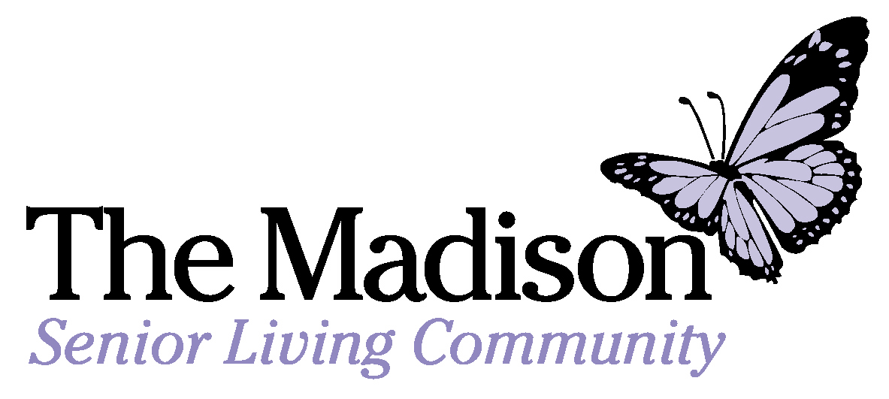 | Help support Gavin and his family  100% of all donations to the family  Homemade Chili and Cornbread  351 Keny Blvd  London, Ohio 43140  740-845-0145

